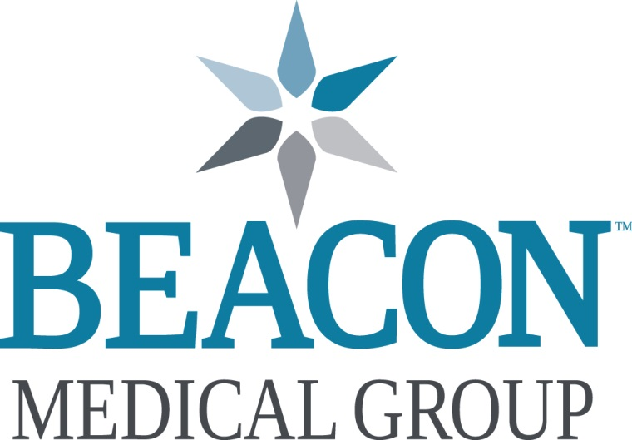

Pediatric Hospitalist
South Bend, Indiana

Want to be awesome too? Beacon Children’s Hospital, a Beacon Medical Group practice, is seeking a Full-time Pediatric Hospitalist to join an existing group of seven (7) awesome pediatric hospitalists, providing evidence-based, high quality care in Northwest Indiana. This hospitalist group has been practicing and growing since 2007. The schedule is comprised of in-house 12-hour, 10-hour and 6-hour shifts. Responsibilities include general and subspecialty pediatric care, as well as moderate sedation. No NICU, nursery, or delivery coverage. Pediatric specialty care at Beacon includes Neurology, Neurosurgery, Psychiatry, ENT, Pulmonology/sleep medicine, Gastroenterology, Infectious disease, and Hematology/oncology.

Beacon Children's Hospital is the regions only designated children's hospital and cares for children with a wide variety of medical and surgical diagnoses from more than 20 referral hospitals throughout Southwestern Michigan and Northern Indiana. Our world-class team includes a complement of other pediatric subspecialties; those include neurology, anesthesiology, behavioral/developmental, child and adolescent psychiatry, pulmonology, infectious disease, gastroenterology, hematology oncology, and neurosurgery; as well as child life specialists, diabetic educators, dietitians and social workers. During 2017, we opened a new children’s hospital - a $46 million effort 109 bed facility with 101,530 square feet, which is crucial to serving thousands of children and their families in a 22-county region.

Beacon Children’s PICU is also an actively involved in several national multicenter quality improvement collaboratives like the Improving Pediatric Sepsis Outcomes (through the Children’s Hospital Association) and the Solutions for Patient Safety (SPS) initiative.

Memorial hospital is 737-licensed-bed hospital has more than 600 physicians on staff representing over 50 medical specialties. Memorial Hospital has been honored numerous times for its quality patient care, including recognition as the #4 ranked hospital in Indiana by U.S. News&WorldReportin2019. Highlights include:

▪ Level II Trauma Center ▪ Dedicated Adult Critical Care, Neonatal, Maternal and Pediatric ▪ Transport Teams ▪ Memorial MedFlight ▪ Advanced Certification as a Thrombectomy-Capable Stroke Center: First and only in Indian ▪ Memorial Regional Breast Care Center ▪ Memorial Hospital Surgery Center ▪ DaVinci Robotic Surgery ▪ Hybrid Operating Suites ▪ Memorial Regional Cancer Center ▪ Blue Distinction Center + Maternity Care Program • Designated Baby-Friendly Birth Facility ▪ Primary Stroke Center

Beacon offers a market competitive salary and benefit package, including, but not limited to:
• Medical, Dental, and Vision Insurance • Life Insurance • Short/Long-term Disability • CME Allowance • 403(b) and 457(b) Retirement Savings Plans • Paid Malpractice with Tail Coverage • and if applicable: Relocation Allowance • Student Loan Repayment Assistance

Beacon Health System locations span across north central Indiana and into southwest Michigan. We are one of the top 2% of hospitals nationwide to achieve a 5 Star CMS Hospital Rating and a AA- bond rating, placing Beacon in the top 10th percentile of health systems across the country. Our physicians and associates enjoy the vibrant surrounding communities which include Elkhart, Granger, LaPorte, Mishawaka and South Bend. Our area is home to several colleges, including the world-renowned University of Notre Dame, providing many options for athletic and cultural events. Combined with the Morris Performing Arts Center in South Bend and the Lerner Theatre in Elkhart, live entertainment is easy to find. A “big little town,” South Bend is also home to the South Bend Cubs, a Class-A minor league baseball team. Parks, Potawatomi Zoo and numerous festivals offer family-friendly fun. Nearby, the sandy shores of Lake Michigan beckon with opportunities for camping, hiking or just relaxing. And, with Chicago just 90 minutes away by car or rail, options for weekend getaways are endless.

For more information, or to submit your CV, please contact:
Caren Foster, Director Physician Recruiting
• Office: 574-647-1647 • Cell: 318-465-6445 • Email: cjfoster@beaconhealthsystem.org
MISSION: We deliver outstanding care, inspire health, and connect with heart.
VALUES: Trust / Respect / Integrity / Compassion
Personally Connect, Keep everyone informed, Be on their team

